PROJECT LIFELINE

An off grid resilient communication system for emergency
coordination when conventional infrastructure is unavailable.

EN-3 Final Project Report
Prepared by:
Ariyasingha NRTS – 250040V
Bandara DMPI – 250066F
Arnigan Y – 250041B
Arnihan S – 250042E

Department of Electronic & Telecommunication Engineering
University of Moratuwa
10/22/2026
Abstract
Natural disasters can disrupt cellular networks, internet connectivity and electrical power when communication methods are mostly needed.

Contents
- Introduction
  - Problem statement
  - Our solution
  - Objectives
  - Constraints and Assumptions
- Technical Background
  - Limitations of currently used communication methods
  - Why LoRa?
  - High level system architecture
  - How does mesh prevents loops?
  - Hardware
  - Schematics
  - Acknowledgement (ACK) and retry protocol
- User guide for Nodes
- Requirements analysis and System Design

- Introduction
Problem statement
Natural disasters can corrupt the regular communication grid. Sometimes disaster relief stations cannot identify who and where are the survivors, is there any other secondary disaster happened in those disaster isolated areas.
As an example when Sri Lankan people faced Ditwah, Out of roughly 16,000 mobile transmission towers nationwide, over 4,000 main towers went completely inactive. Millions of users across districts like Nuwara Eliya, Badulla, Kandy, Puttalam, and Vavuniya were left completely isolated without cellular or internet connectivity, severely hampering emergency coordination. Even some of our closest friends also unabled to get informed about their family.

What is our solution?
Our solution is distribute a device called Node around a country and keep them online. When a part of the district got isolated people can connect with the nearest Node with their phone and send SOS message to nearby disaster relief center. Node uses radio mesh network to reach further distances. So that network cannot be isolated easily.

Objectives
- Develop a node architecture using a suitable microcontroller and a radio transceiver.
- Implement message addressing, message identifiers, location sensor data extractions.
- Creating a user friendly mobile application and displaying delivery status.
- Developing a mesh network that do not repeat a successfully sent message.
- Repeatable field test procedure
Constrains and assumptions
- Performance depends on the environment whether it is a plain or terrain, urban or rural and the number of active Nodes.
- Nodes are assumed to be operated by trained users and they do not supply wrong information.
- It is assumed that users will not misuse these legally un-logged and uninterrupted communication systems.

- Technical Background
Limitations of currently used communication methods
Communication systems range from public cellular networks and satellite systems to professional land mobile radio (Walkie talkie), armature radio (ham radio), pagers etc.
Cellular networks are vulnerable for majority of disasters. They could be easily go down. Satellite systems require compatible equipment, clear sky view for many services, subscription or airtime arrangements, and additional cost.
Professional radio systems are robust but requires licensed operators, repeaters and expensive equipment.
A small radio mesh that controlled with a user friendly application in their phone can be a good solution in this case.
Why LoRa?
LoRa (Long Range) is a technology developed for send small amount of data over long distances using very little power.
Here are some rough ranging data of LoRa according to environment
- Rural / Open Countryside: 10 km to 20+ km
- Suburban Areas: 5 km to 10+ km
- Dense Urban / Smart City: 1 km to 5 km
- Mountainous / Forested Terrain: 5 km to 10 km
- Indoor / Multi-wall Buildings: 100 m to 1 km

High-Level System Architecture
When a user send a sos message through their mobile phone, the application formats the message and combines users current location with the GPS sensor in their phone. And send it via BLE to the microcontroller.
Microcontroller forwards the exact BLE message with the LoRa module to the air.
Case 1
If the disaster relief station is in the range of the Node operator, then the SOS directly hit the LoRa transceiver in the Command Center device in disaster relief station.
Case 2
If the disaster relief center is not in the range and if there is another Node in the range then the data packet hits that LoRa module, check where it come from and add the data packet where it landed and again release it into the air. And this process repeats until the data packet hit the command center.
Finaly after the data packet received to the command center computer, it processes the data packet and extract where it comes from, what is the emergency type, and updates it in the map window. Then it sends a message that the sos has been received. That message also hops between other nodes and hit the target node.

How does mesh prevent loops?
When a sos received to a node, then it checks the node history in the message (during hopping the current node number is combined to the message). If the current node in the node history it means the same message previously transmitted by the node. So it ignores the message.
If the same message (detects by checking the time in the message) came from two separate paths, then that message also been transmitted by the node. So that also ignored.
When the node received a message and if the distance from the disaster relief center and the coordinates in the message (the origin) is lower than the distance between the current node and the disaster relief center then the message get ignored. Because the message is transmitting away from the destination.
Hardware
Field Node
- ESP32 microcontroller  - Ra-02 SX1278 433MHz LoRa module | For handle Bluetooth connectivity and control LoRa module  For long range radio communication and reduce the cost

Command center (Central Node)
- Raspberry Pi  - Ra-02 SX1278 433MHz LoRa module | For handle massive number of data coming from hundreds of field nodes. And make the command center device portable.

Pin Configurations
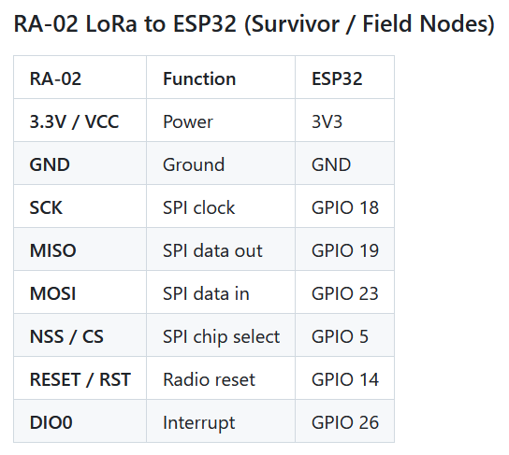

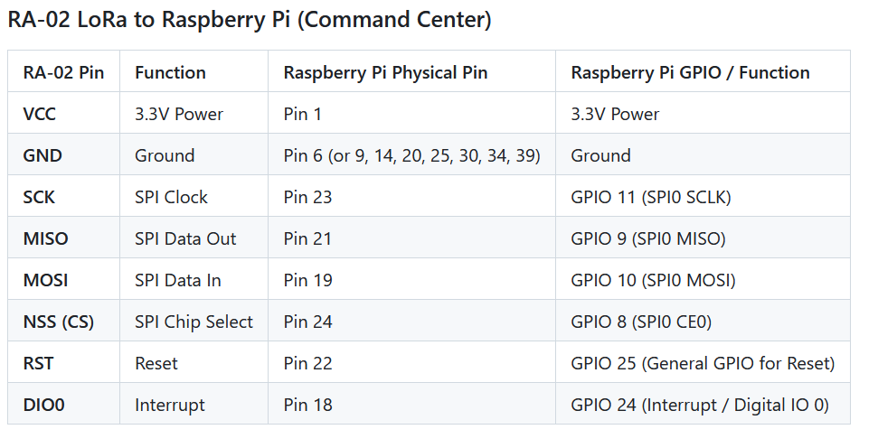
Schematics

The Acknowledgement (ACK) and Retry Protocol
After a message sent to the command center server, then the server broadcasts the NIC number + message number (hashed and encrypted) back. If the origin node of the message received that it checks the hashed and encrypted NIC number + message number, then the node knows the previous message has been sent successfully.
Example
SOS Message format:
<Node chain>: [SOS] : <message id> : <timestamp> | <alert> | GPS: <lat, lon>
ACK Message format:
Node chain: [ACK] : <a base85 string of the sha256 hash of the current users NIC number with the message number>
We use the SHA256 hashing to secure the NIC and base85 encryption to shorten the hash.
Until the ACK message receive the Node continuously send the same message with 5-minute intervals. After the acknowledgement that retrying stops.
This protocol is implemented to ensure the data reached destination safely.

- User guide for Nodes
- User should have the LifeLine application in their mobile phone
- First Log in to your application by adding your NIC number.
- Connect to the Node with the application. The node is shown as LifeLine_Node_XXX
- After a successful connection the user can select the emergency type and click send button.
- And wait for the message sent notification. Do not try to click more and more times if the notification did not came. The device will repeat your message until a valid response.

